Revolutionizing Apartment Design: Immersive VR and AR Exploration

19CSE439 - AUGMENTED REALITY AND VIRTUAL REALITY

Abineha P
Department of Computer Science
and Engineering
Amrita School of Computing, Coimbatore
Amrita Vishwa Vidyapeetham
India.
cb.en.u4cse21201@cb.students.amrita.edu
Tadepalli Sri Valli Ramya
Department of Computer Science
and Engineering
Amrita School of Computing, Coimbatore
Amrita Vishwa Vidyapeetham
India.
cb.en.u4cse21263@cb.students.amrita.edu

Suruthi Lavanya A
Department of Computer Science
and Engineering
Amrita School of Computing, Coimbatore
Amrita Vishwa Vidyapeetham
India.
cb.en.u4cse21262@cb.students.amrita.edu
M K Eniyan
Department of Computer Science
and Engineering
Amrita School of Computing, Coimbatore
Amrita Vishwa Vidyapeetham
India.
cb.en.u4cse21435@cb.students.amrita.edu

Abstract— This project aims to change the traditional notion of the house tour experience by integrating visualization of house interiors with an experience of amenities provided in a community. This document will outline the advantages, challenges, and methodology ensuring an understanding of the significance and potential impact.
Keywords— Virtual Reality, Augmented Reality, Immersive Experience, Visualization.

Introduction
In today's rapidly evolving world, the concept of home extends far beyond the physical confines of four walls. It encompasses a rich tapestry of experiences, interactions, and amenities that contribute to a fulfilling lifestyle. Recognizing this paradigm shift, our project aims to transform the conventional house tour experience with an exploration of community services along with interior design visualization through AR and VR. It enables users to explore a virtual tour when searching for a house and community to check its desirability, sparing them the trouble of traffic, time, and dealing with vendors. Another added advantage is that it provides users the option to choose the interiors, enabling them a hassle-free experience by offering a better visual experience and avoiding the need to travel in search of interiors that meet their requirements. However, with great ideas, there come a few challenges, and similarly, there are certain challenges in implementing the proposed idea, such as device compatibility.

Related Work
Virtual reality (VR) tours have emerged as a ground-breaking technology across various industries, revolutionizing how users engage with environments and experiences. From exploring potential real estate properties to navigating historical landmarks, VR tours offer immersive journeys that transcend physical limitations. In recent years, researchers and developers have explored diverse use cases and works harnessing the power of VR tours.
The authors of Augmented Reality-based Furniture Application [1] proposed a solution that offers shopping by integrating physical and virtual environments, offering buyers realistic previews of furniture items in terms of color, shape, and size within their space. This innovative approach enhances user experience by enabling virtual furniture placement, saving time and effort with selections from multiple stores within the app, and increasing buyer confidence through improved decision-making capabilities. However, the implementation of AR technology presents challenges, including technical complexities in rendering accurate AR experiences, accessibility limitations for users without AR-capable devices, dependency on high-speed internet for smooth operation, privacy concerns regarding access to camera and location data, and high costs associated with development and maintenance of the AR app.

In the paper, ‘The Design and Implementation of an Interactive Mobile Augmented Reality Application for an improved furniture shopping experience’ [2], the authors propose a solution that presents the development and application of an augmented reality (AR) furniture app, designed to provide an online furniture shopping by allowing users to visualize furniture in their intended space and address the concerns. Utilizing ARCore and mobile technology, the app provides a virtual preview of furniture in real environments, enhancing buyer confidence and streamlining furniture selection and placement processes. However, the implementation of AR technology poses technical challenges related to accuracy and realism, alongside accessibility limitations for users without AR-capable devices or high-speed internet. Privacy concerns arise from app permissions for camera and location data, while the development and maintenance of the app may incur significant costs due to the complexity of AR technology. Despite these challenges, the app represents a flexible and creative solution to online furniture shopping challenges, with future recommendations including barcode/QR code integration for item identification, surface classification for accurate 3D object display, and improved 3D models for better fit in the virtual space.

The document, ‘The Implementation of Virtual Reality (VR) Technology in Real Estate Industry’ [3] addresses the lack of customized virtual tour systems for higher education institutions in Ukraine by proposing a web application leveraging augmented reality (AR) technology to showcase the facilities and surroundings of Lviv Polytechnic National University. This initiative serves as a direct response to the constraints imposed by the COVID-19 pandemic, offering an innovative solution to promote the university while ensuring cross-device accessibility. Noteworthy advantages include heightened visibility, immersive user experiences, and scalability for future expansions. However, overcoming technical barriers and fostering user adoption presents notable challenges that necessitate careful consideration for successful implementation. Striking a balance between these factors is crucial to fully harnessing the platform's potential for advancing higher education marketing efforts and enriching engagement with prospective stakeholders.

The study in the paper, ‘Formation of Virtual Tours with the Use of Augmented Reality Information Technology’ [4], investigates the impact of the COVID-19 pandemic on the real estate industry, highlighting the necessity for rapid technological adoption to navigate the new normal. It emphasizes the rising prominence of Virtual Reality (VR) as a pivotal tool for real estate agents to enhance marketing strategies, particularly in facilitating property tours and sales agreements amidst social distancing measures. By gathering primary data from 60 real estate respondents and descriptively analyzing it using SPSS software, the study identifies VR tours of properties, 360-degree visualizations, and visualizations of room furniture as key activities needed for effective VR implementation. The findings underscore the importance of VR in providing detailed property information, high-quality photos, and investment opportunities. However, challenges such as technological complexity and user acceptance need to be addressed. Despite these challenges, VR technology offers the potential to revolutionize real estate marketing by providing immersive experiences, streamlining the sales process, and reducing costs associated with traditional marketing initiatives. Thus, the study advocates for the widespread adoption of VR technology in the real estate industry to overcome the challenges posed by the pandemic and thrive in the evolving market landscape.

Methodology

Architecture Model
The image (Figure 1) illustrates the workflow of an augmented reality (AR) system. Starting with a live video feed captured by a camera, the video stream is processed into frames by the Image Capturing Module. These frames are then analyzed by the Image Processing Module to detect markers and determine their positions. The Marker Tracking Module further processes this information to calculate the markers' poses in 3D space. Using this data, the Rendering Module overlays virtual components onto the real-world images, creating an augmented reality view that combines both original and virtual elements. This AR output is then displayed back through the camera or another display device, merging digital and real-world environments seamlessly.
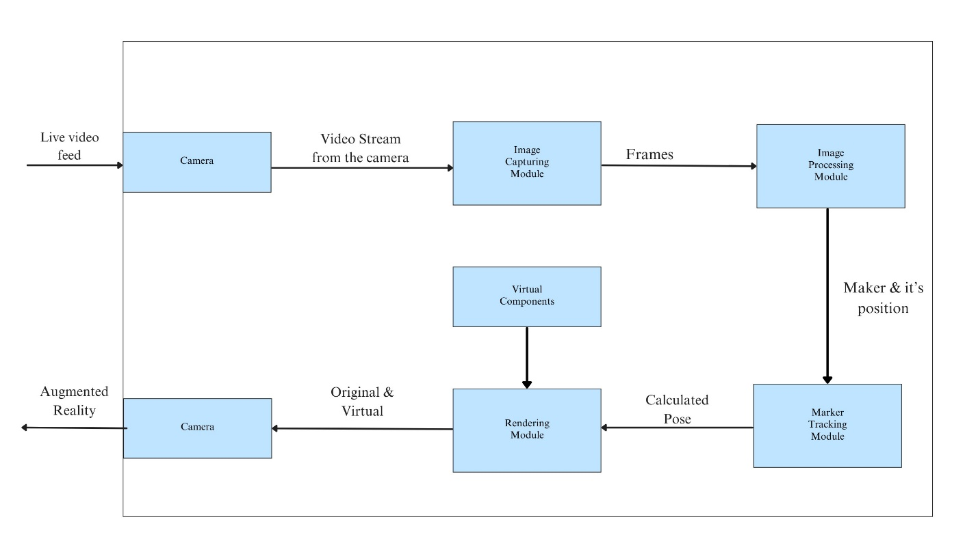
Figure 1 : Architecture Model

Implementation Steps
- Project Initialization
- Environment Configuration (Unity)
- Scene Design
- Scripting for Interactions
- Performance Optimization
- User Interface Design
- Testing and Refinement

Algorithms for furniture placement

Collision Detection:
Algorithms are used to detect collisions between furniture items and the environment, ensuring that objects do not intersect.

Continuous Collision Detection (CCD):

CCD is used to detect collisions between fast-moving objects that may pass through each other in a single time step.

One common CCD technique is linear interpolation, where the positions of objects are interpolated between their current and previous positions to detect collisions that occur during movement.

Unity provides CCD support for rigid body collisions. By enabling continuous collision detection on rigid bodies, Unity ensures that fast-moving objects are checked for collisions accurately.

Snap-to-Grid: Logic for snapping furniture items to a grid or other alignment guides to ensure precise placement.

Algorithms for Performance Optimization

Occlusion Culling: Occlusion culling techniques are employed to selectively render only the objects visible to the user, improving performance.

Visibility Determination:
- Before rendering a frame, the visibility of objects in the scene is determined relative to the camera's view.
- Occlusion culling algorithms analyze the scene geometry to identify occluders—objects that block the view of other objects from the camera's perspective.
- Techniques such as view frustum culling are used to quickly discard objects that are outside the camera's view frustum and are not visible to the user.
- Unity Engine provides built-in occlusion culling features and tools for configuring and optimizing occlusion culling settings to improve rendering performance.

Proposed Concepts

Augmented Reality (AR):
Tracking: ARCore utilizes visual features in the physical environment to track the device's position and orientation through a technique known as simultaneous localization and mapping (SLAM).

- Feature Detection: Analysing the camera feed to detect distinct visual features in the scene, such as corners, edges, or unique patterns. These features serve as reference points that ARCore can use to anchor virtual objects in the physical environment.

- Feature Tracking: Once ARCore has detected visual features in the scene, it tracks their movement over time as the device moves. By continuously matching these features with previously identified ones, ARCore can estimate the device's relative motion and position in the physical world.

- Pose Estimation: ARCore uses the tracked visual features to estimate the device's pose, which includes its position (x, y, z coordinates) and orientation (roll, pitch, yaw angles) in 3D space relative to a fixed coordinate system. Solving complex mathematical equations to determine the best-fitting pose that aligns the observed visual features with their expected positions.

- Map Building: As the device moves through the environment, ARCore simultaneously builds and updates a 3D map of the surroundings using the detected visual features. This map, known as the spatial map or point cloud, provides additional context for tracking and helps ARCore maintain accurate pose estimates even in dynamic or feature-poor environments.

- Optical Flow and Inertial Sensors: In addition to visual feature tracking, ARCore may also utilize data from the device's inertial sensors and optical flow algorithms to refine pose estimates and improve tracking accuracy, especially during rapid movements or when visual features are sparse.

Virtual Reality (VR):

Rendering: Rendering pipeline in VR, including stereo rendering for depth perception and techniques for reducing motion sickness.

Stereo Rendering:
Unity's VR rendering pipeline automatically handles stereo rendering by rendering the scene from two separate camera perspectives, one for each eye.

Each camera is positioned slightly apart to mimic the distance between human eyes, providing the necessary parallax for depth perception.

Unity's VR integration ensures that the rendered images are correctly distorted to account for the lens distortion of the VR headset, ensuring a seamless and accurate view for the user.

Interaction Models: Describe common interaction models in VR, such as Raycasting, hand tracking, and controller-based interactions.

Ray casting:
Ray casting involves projecting a virtual ray or line from the user's controller or gaze direction into the virtual environment. When the ray intersects with a virtual object, it can trigger interactions such as grabbing, pointing, or selecting. Unity provides built-in ray-casting functionality through the Physics.

Hand Tracking:
Unity's Hand Tracking SDK, such as Oculus Hand Tracking or SteamVR Input, provides APIs and components for integrating hand tracking into VR applications. These SDKs offer features for detecting hand gestures, tracking hand poses, and interacting with virtual objects using natural hand movements.

Experimental Results

Implementation:
The below images (Figure 2(a), Figure 2(b)) are screenshots of the implementation of the application generated by Unity.

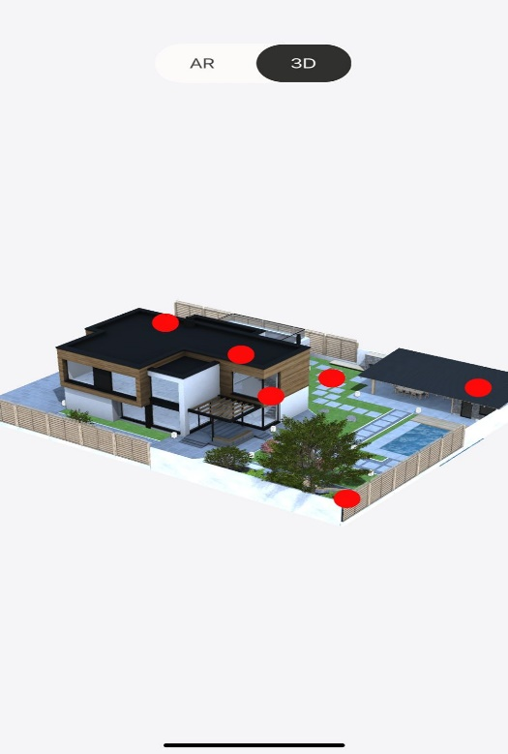

Figure 2 : Home page of the App

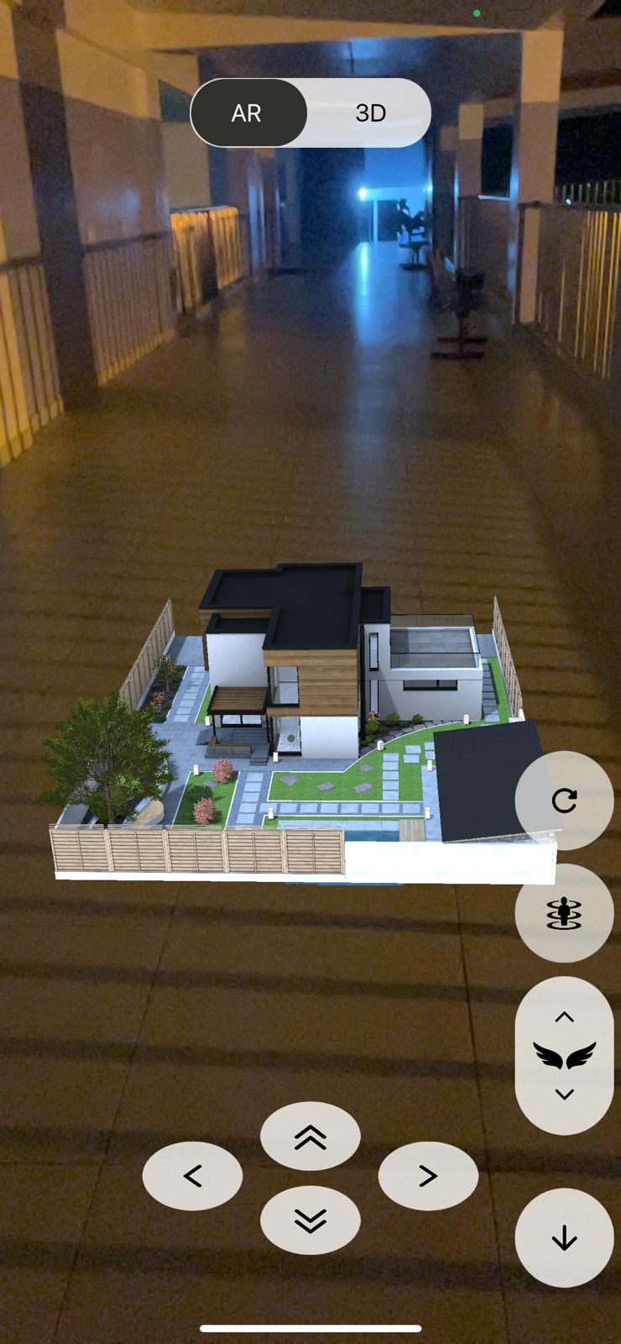

Figure 3 : AR view of the model

Performance Metrics

Latency Assessment:

Finding: No discernible latency was observed between user action and system response.

Evaluation: The gyro and magnetometer of the iPhone provided an immediate response, indicating efficient hardware performance

Latency Assessment:

Observed Rate: Consistently achieving 60 Frames per second(fps).

Evaluation: The application demonstrates smooth rendering and real-time interaction, meeting industry standards for AR applications.

Frame Rate:

Observed Rate: Consistently achieving 60 frames per second (fps).

Evaluation: The application demonstrates smooth rendering and real-time interaction, meeting industry standards for AR applications.

Resolution and Image Quality:

Resolution: Utilizing device-native resolution for rendering.

Image Quality: High-definition visuals with sharp details and vibrant colors.

Tracking Accuracy:

Assessment: Tracking accuracy is consistently high, with minimal drift or jitter during interactions.

Evaluation: The AR application effectively registers and tracks real-world objects, providing a seamless overlay of virtual content.

System Reliability and Stability:

Observation: The application demonstrates robust stability during extended usage periods.

Evaluation: No crashes or significant performance issues were reported during testing.

Scalability:

Scalability: The current design of the application accommodates the presentation of one model seamlessly.

Future Expansion: Plans are in place to extend the application's capability to incorporate additional models for diverse architectural visualization needs.

Accessibility:

Accessibility Features: The application prioritizes accessibility, ensuring inclusivity for all users.

Enhanced Navigation: Buttons are provided within the interface to facilitate seamless transitions between 3D model viewing and Augmented Reality (AR) modes, enhancing user flexibility and accessibility.

Optimized Interaction: In AR mode, users have the option to navigate through the virtual building using 6 Degrees of Freedom (DoF) controls, enabling movement within the space. This feature caters to users who may prefer either walking or stationary viewing experiences.

Conclusion
The final product of our project provides the user with an AR virtual home tour along with which it enables the user to choose the interiors of the home during a real-time property visit. This is made possible using algorithms like Collision Detection, Continuous Collision Detection (CCD), Snap-to-Grid, Stereo Rendering, Ray casting, and Hand tracking. The product showcases an exemplary performance about tracking accuracy, latency, frame rate, etc., but has its limitations when it comes to accessibility as it is own accessible to IoS mobile users. A possible extension to the project will be combining the provision of a selection of interiors along with a virtual home tour

Reference
[1] S. Gubbala, D. N. Alti, S. Srividhya, and S. Pothumani, “Augmented Reality based Furniture Application,” in Proceedings of the International Conference on Advanced Artificial Intelligence and Computer Science (ICAAIC), May 2023, pp. 1088-1092. DOI: 10.1109/ICAAIC56838.2023.10140655

[2] B. Alharbi, N. Aljojo, A. Alshutayri, A. Banjar, A. Zainol, A. Alharbi, S. Alghanmi, S. Mansour, and M. Alshehri, “The design and implementation of an interactive mobile Augmented Reality application for an improved furniture shopping experience,” Revista Română de Informatică și Automatică, vol. 31, no. 3, pp. 69-80, Sep. 2021. DOI: 10.33436/v31i3y202106

[3] K. Kholim, A. S. Sukereman, S. Rosman, and N. Jaafar, “The implementation of virtual reality (VR) technology in real estate industry,” Planning Malaysia, vol. 21, no. 27, pp. -, Jul. 2023. DOI: 10.21837/pm.v21i27.1299

[4] R. Bakhmut, N. Kunanets, A. Rzheuskyi, V. Pasichnyk, V. Kut, O. Volkov, and I. Tsmots, “Formation of Virtual Tours with the Use of Augmented Reality Information Technology,” in Proceedings of the Conference on Learning and Intelligent Systems (COLINS), 2021, pp. 1431-1443

